DB design using SQL workbench:

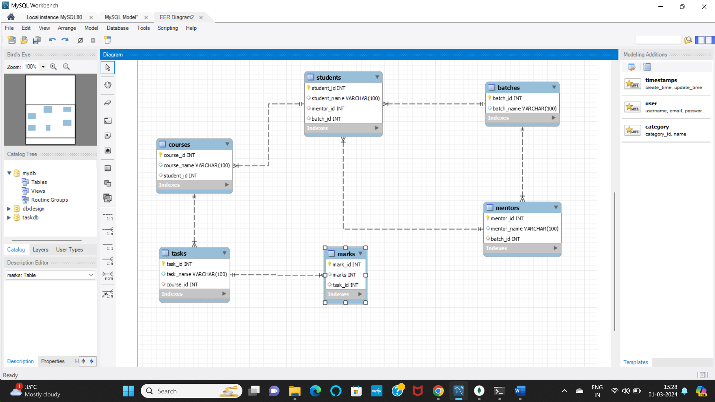

Queries for the design shown above:

* create table batches (batch_id int primary key, batch_name varchar(100));
* create table mentors (mentor_id int primary key, mentor_name varchar(100), batch_id int, foreign key(batch_id) references batches(batch_id) );
* create table students (student_id int primary key, student_name varchar(100), mentor_id int, foreign key(mentor_id) references mentors(mentor_id), batch_id int, foreign key(batch_id) references batches(batch_id));
* create table courses (course_id int primary key, course_name varchar(100), student_id int, foreign key(student_id) references students(student_id));
* create table tasks (task_id int primary key, task_name varchar(100), course_id int, foreign key(course_id) references courses(course_id));
* create table marks (mark_id int primary key, marks int, task_id int, foreign key(task_id) references tasks(task_id) );